**Using VLSM design ( Variable length subnet mask )**

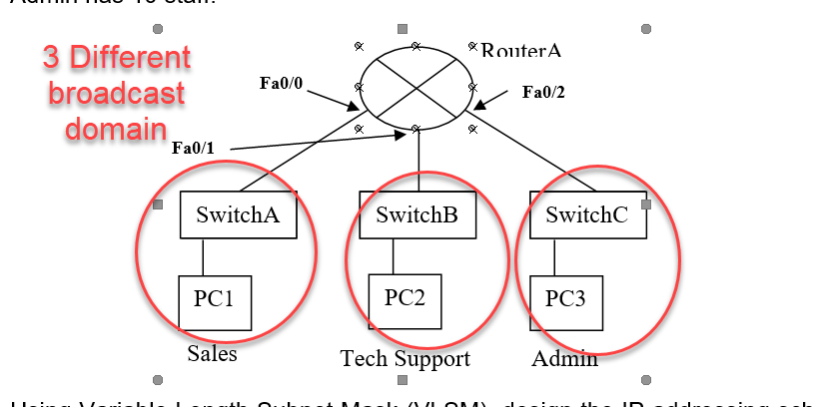

**GOLDEN RULE MUST BE DESCENDING**

|  |  |  |  |  |  |  |  |  |  |
| --- | --- | --- | --- | --- | --- | --- | --- | --- | --- |
| **LAN or WAN name** | **No of hosts needed for each subnet** | **Min no of host bits needed** | **/ prefix** | **Resultant Subnet mask** | **Entire full size of my subnet (aka magic no)** | **Subnet address** | **1st IP address** | **Last IP address** | **Broadcast IP** |
| **Sales dept LAN** | 50 | 6 | 32 – 6 = /26 | 11111111.11111111.11111111.11000000  255.255.255.192 | 256 – 192 = 64 | 192.168.1.0 | .1 | .62 | .63 |
| **Tech Support LAN** | 25 | 5 | 32 – 5 = /27 | 11111111.11111111.11111111.11100000  255.255.255.224 | 256 – 224 = 32 | 192.168.1.64 | .65 | .94 | .95 |
| **Admin LAN** | 10 | 4 | 32 – 4 = /28 | 11111111.11111111.11111111.11110000  255.255.255.240 | 256 – 240 = 16 | 192.168.1.96 | .97 | .110 | .111 |
|  |  |  |  |  |  | 192.168.1.112 |  |  |  |
|  |  |  |  |  |  |  |  |  |  |
|  |  |  |  |  |  |  |  |  |  |